A. Basic Git Commands (For managing repositories)
1) git init: Initializes a new Git repository in the current
directory.
Run this command inside your project's root folder to begin tracking
Command: git init
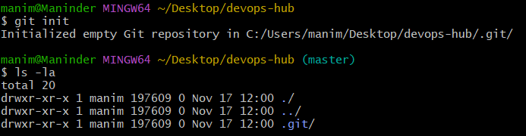
2) git clone <repo_url>: Clones a repository from a remote URL to your local machine.
Run this with the URL of a remote repository (e.g., from GitHub) to create a local copy.
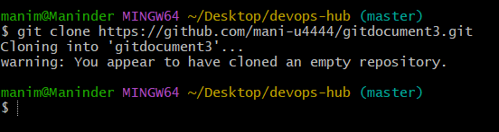
3) git status: Shows the working directory status (which files are
modified, staged, etc.).
Execution Step: Run this command frequently to check which files have changes.
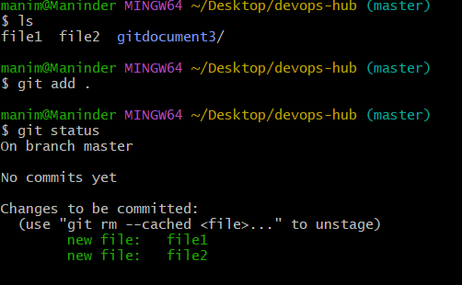

4) git add : Stages a file or files to be committed.
5) git commit -m "message": Commits staged changes to the local repository with a message..
Execution Step: After staging files with git add, run this to save them as a snapshot in your local history. Always include a clear, descriptive message.
git commit -m "this is the initial commit"
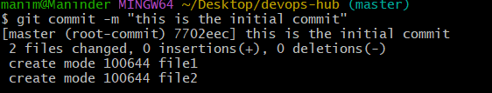
6) git push: Pushes committed changes to the remote repository.
Execution Step: Use this to upload your local commits to the shared remote repository, making them available to your team.
I have added the remote repo using the command: git remote set-url origin git@github.com:mani-u4444/gitdocument3.git
git push -u origin main

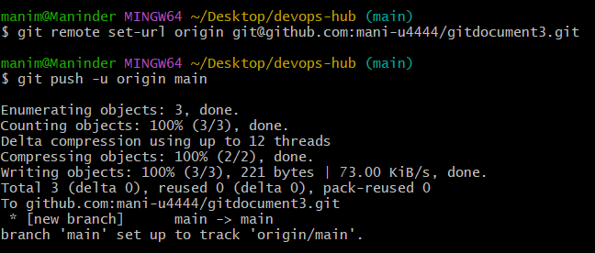
7) git pull: Fetches and merges changes from the remote
repository to your local working directory.
git pull
Run this before starting new work to ensure your local copy is up-to-date with the team's changes
Checked ls -la in the local directory and also created a file3 in the github and executed the git pull command to pull the file3 to the local directory
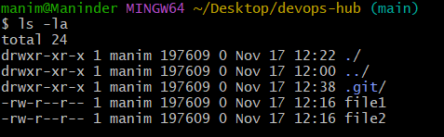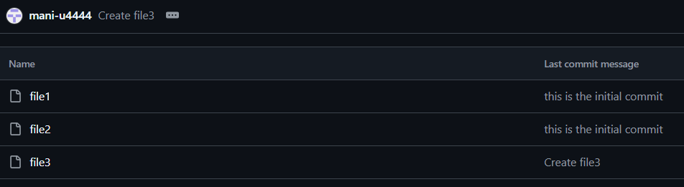
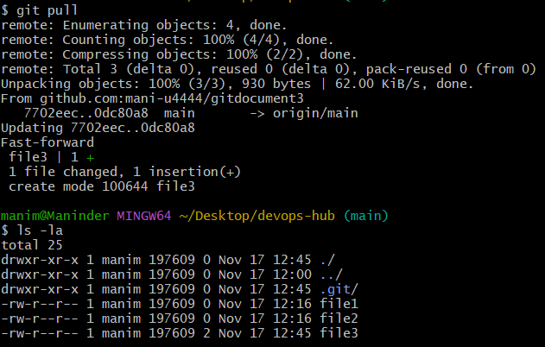

8) git fetch: Downloads objects and refs from another repository
(without merging).
Downloads new commits and branches from the remote, but does not merge them into your current branch.
I have made a commit for the file3 in the github and I have executed git fetch to pull the commit history from the github to the local repo
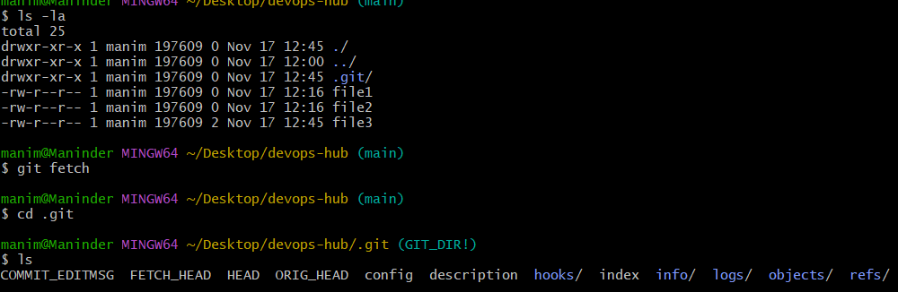
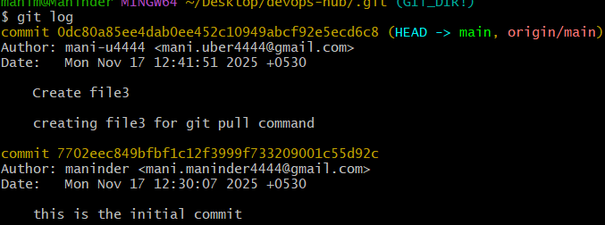

9) git merge: Merges changes from the specified branch into the
current branch.
I have created two files file4 and file5 in hotfix branch and executed git add. And git commit, switched to release branch and executed the git merge hot fix command to merge the committed files to the release branch.
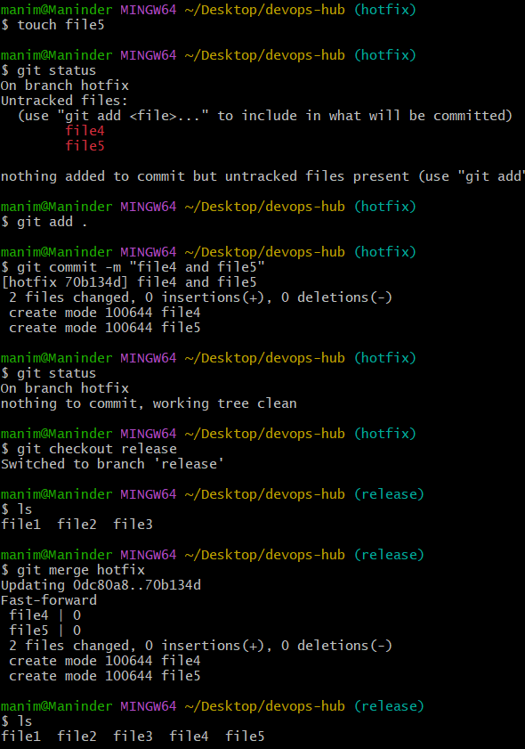

10) git log: Shows the commit history of the repository.
Command : git log
This command will show all the commit history
11) git diff: Shows the differences between your working
directory and the index (staged changes).
Command executed: git diff
Initially the content of the file5 was ‘hello’ and I have moved the file to index location now changed the file5 to ‘hello world’ and now executed git diff to see that
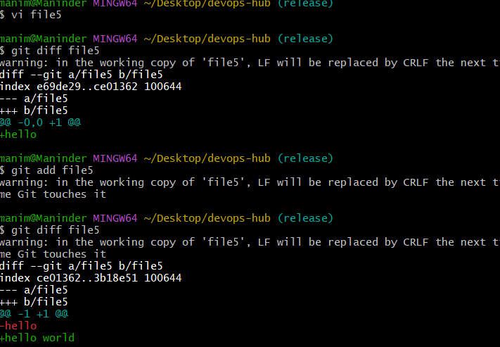
B. Branching Commands (Managing branches)
12) git branch: Lists all branches in your repository.
Command: git branch –list
This command will list all the branches present in the local repo
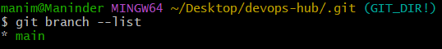
13) git branch <branch_name>: Creates a new branch.
Command: git branch release #release is the name of the branch created from the main branch
Created the branch named release and we can see all the files of the main branch as it is created from the main branch
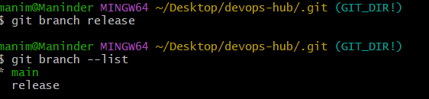
15) git checkout <branch_name>: Switches to an existing
branch.
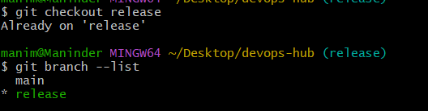
16)git checkout -b <branch_name>: Creates and switches to a
new branch in one step.
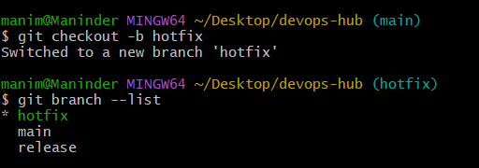
17) git merge <branch_name>: Merges changes from the
specified branch into the current branch.
I have created two files file4 and file5 in hotfix branch and executed git add. And git commit, switched to release branch and executed the git merge hot fix command to merge the committed files to the release branch.

18) git rebase <branch_name>: Applies changes from one
branch onto another branch (instead of merging).
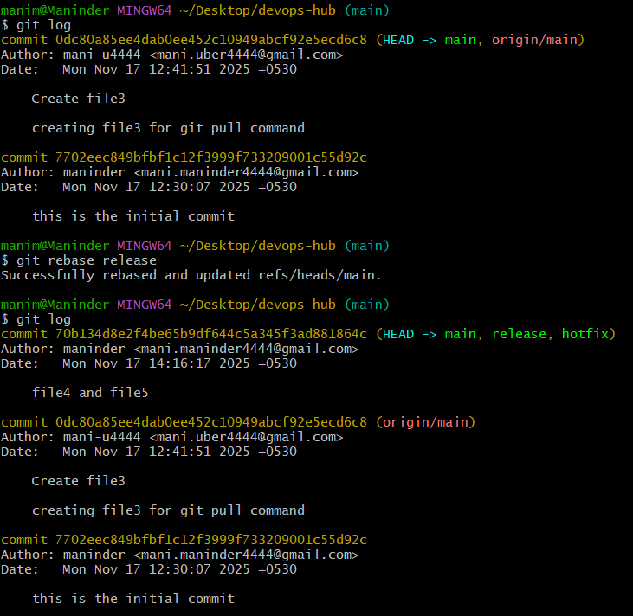
Git rebase wll allow you to rewrites the project history by moving or combining a sequence of commits to a new base commit.
Previously only 2 commits were in the main branch and 1 commit on creating file4 and file 5 in release branch, now if we execute the git rebase release from main branch we can see there are 3 commits in the main directory.
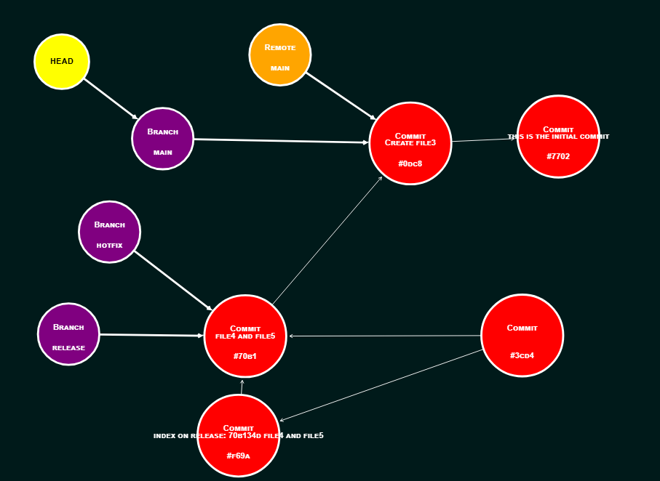
Before git rebase the main is pointing to commits file3 and initial commit
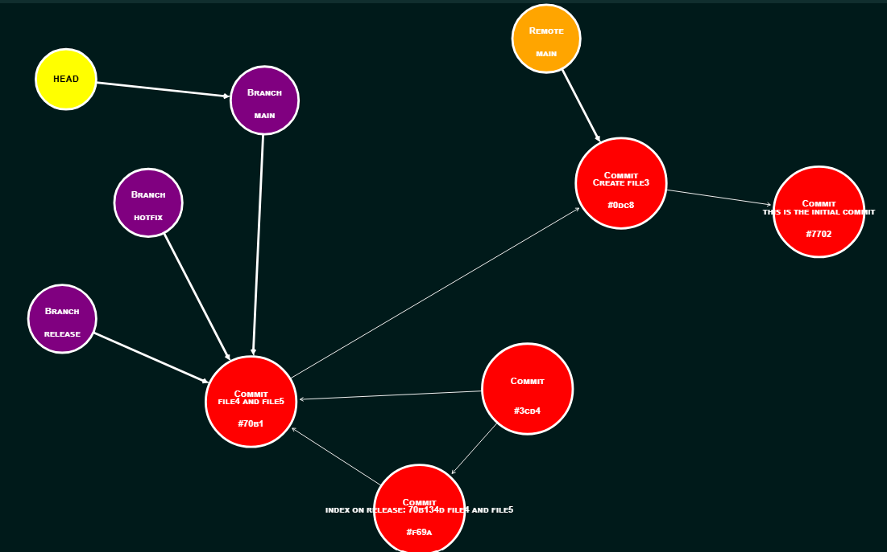
After the git rebate the main Is pointing to commit file4 and file5 commit done by release branch and git log will show the all the commits connected to one another.

19) git branch -d <branch_name>: Deletes the specified branch
(locally).
Executed command: git branch -d hotfix

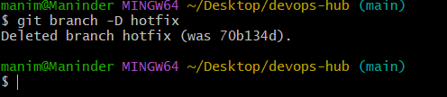

20) git branch -D <branch_name>: Forcefully deletes a branch
(locally).
Executed command: git branch -D hotfix

21) git remote set-head origin <branch_name>: Sets the
default branch for the remote repository.
git remote set-head origin <branch_name>: This command explicitly sets the specified <branch_name> as the default branch for the remote repository. This is useful if you want a different branch to be checked out by default when someone first clones the repository or runs certain fetch operations.

3. Remote Commands (Managing remotes and syncing
with the cloud)
22) git remote -v: Shows the remote repository URLs.
git remote add origin https://github.com/mani-u4444/gitdocument3.git
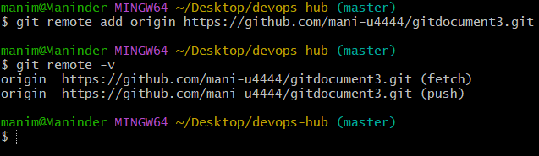
23) git remote add : Adds a new remote repository.
24) git remote remove : Removes a remote repository.
git remote remove origin will remove the repository named with alias origin and I have executed git remote -v to see if it is deleted or not.
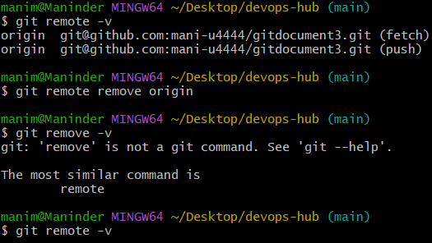

25) git push origin <branch_name>: Pushes a branch to a
remote repos
I have executed git pull origin release to fetch the repository details and initiated fit ppush origin release to sync the contents in the release branch in the local to the release branch in the remote repo
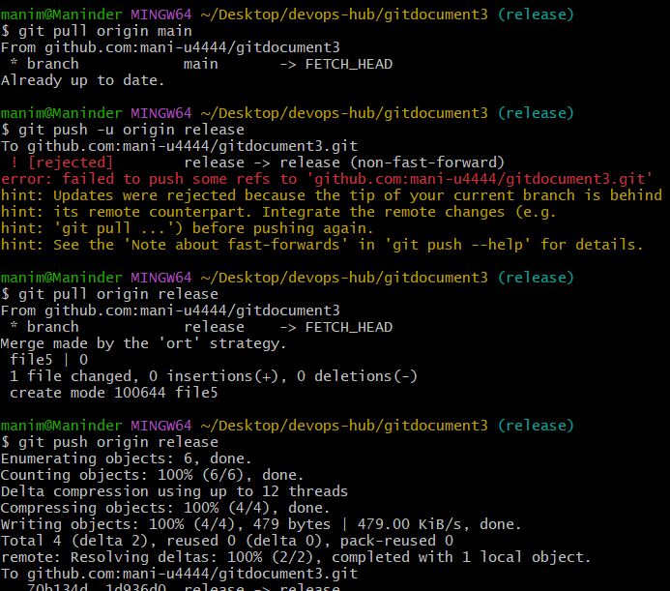

26) git push -u origin <branch_name>: Pushes a branch to a
remote repository and sets the upstream for the branch.
Commands executed: git push -u origin release to create the new upstream
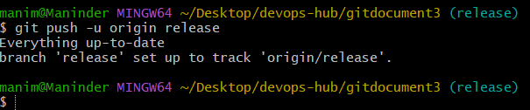

27) git pull origin <branch_name>: Fetches and merges a
branch from the remote repository.
I have created a file named filefromreleasegithub in the release branch in the github repository and now executed the command git pull origin release in the release branch in the local repo and on executing the ls command we can see the file created in the github
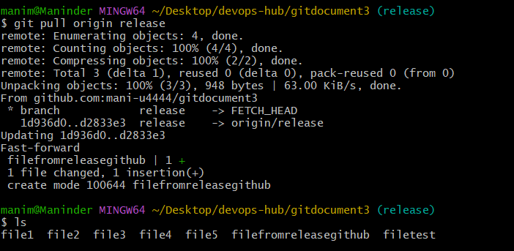
28) git fetch origin: Downloads objects and refs from the
remote repository.
I have executed the git fetch command to fetch the configuration details of my remote repo on to my local repo
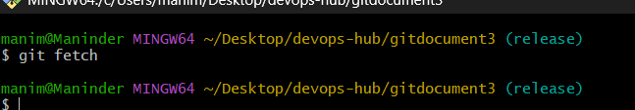

29) git remote show origin: Displays detailed information
about a remote repository.
I have executed git remote show origin and we can see that all the configuration details of main and release branches are up to date.

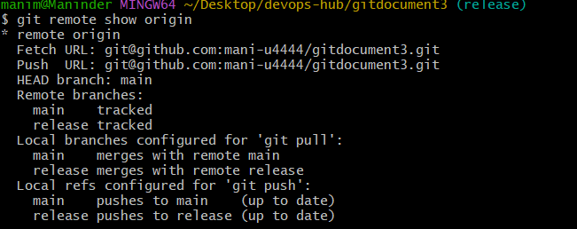
D. Staging and Committing (Managing changes)
30) git add . : Stages all modified files in the working directory.
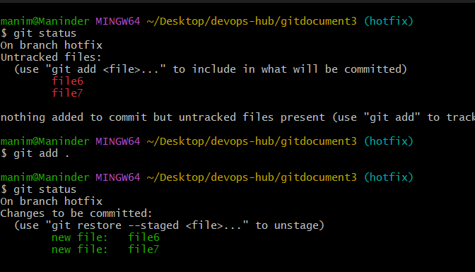
32) git add -A: Stages all modified files (including file deletions).
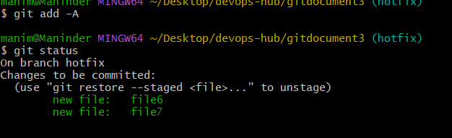
33) git reset : Unstages a file (reverts it to the working directory).
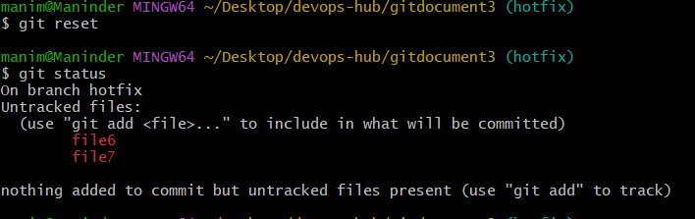
34) git commit --amend: Modifies the last commit (can change
the commit message or add changes).
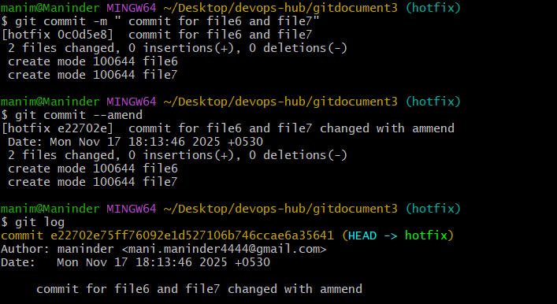
35) git commit --all: Automatically stages tracked files and
commits them.
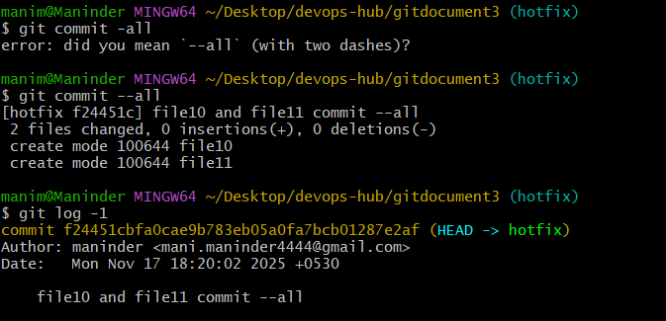

36) git commit -a: Stages and commits all modified files.
Modified the contents of file1 and file2 and executed git commit -a to automatically stage and commit only the modified files.
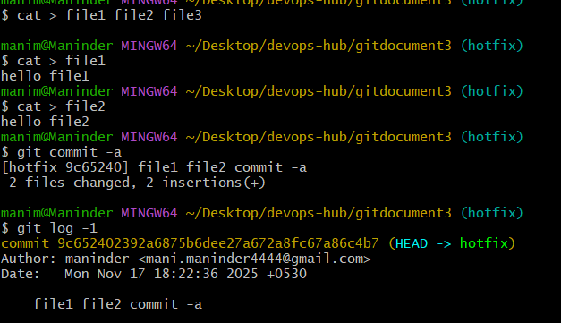
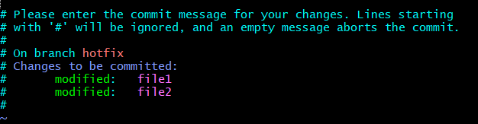

37) git commit --no-verify: Skips pre-commit hooks while
committing.
A pre-commit hook is a script that runs automatically before a code commit is finalized in a version control system like Git. Its purpose is to check code for errors and enforce standards, such as linting, formatting, and running quick tests. If the hook fails, the commit is aborted, preventing bad or inconsistent code from being added to the repository and giving the developer a chance to fix the issues 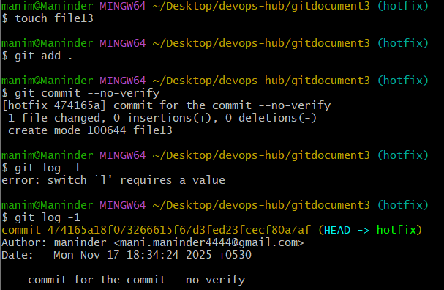

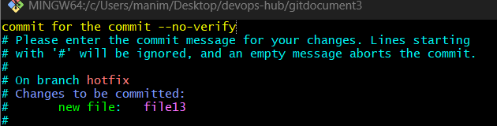
38) git reset --soft HEAD~1: Moves the HEAD pointer back
one commit but leaves your changes staged.
I have created a file named file14 and fed “ This is the working directory file for soft reset” executed git add and committed the file
Next I have appended the file14 with “reset changed for demo”, and executed git add and committed the file.
now i execueted git reset –soft HEAD~1 and now execueted the git dif –staged.
The file in the staging area got rolled back to previous commit content but the file in the working directory stayed intact
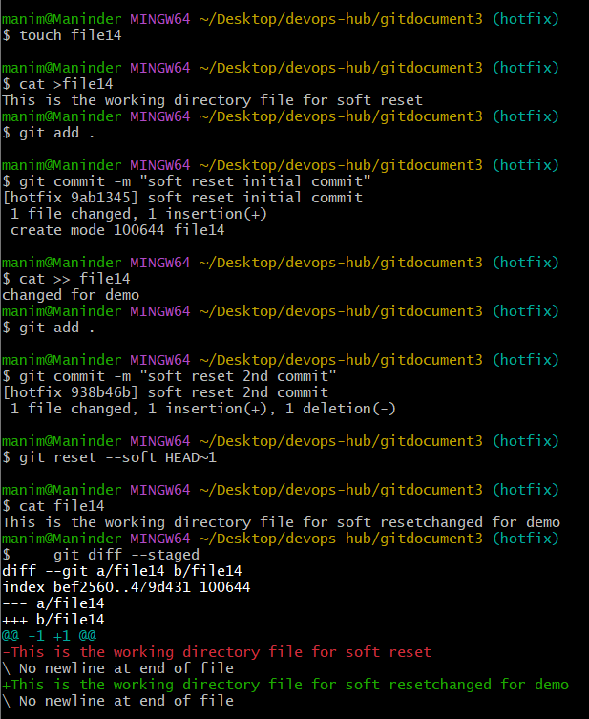

39) git reset --hard HEAD~1: Moves the HEAD pointer back
one commit and discards changes in the working directory.
I have created a file named file15 and fed “ This is the working directory file for hard reset” executed git add and committed the file
Next I have appended the file15 with “reset changed for demo”, and executed git add and committed the file.
now i execueted git reset –hard HEAD~1 and now execueted the git dif –staged, and I can see there are not changes to the staged file.
The file in the staging area and working directory both got rollbacked to the previous content in the previous commit. 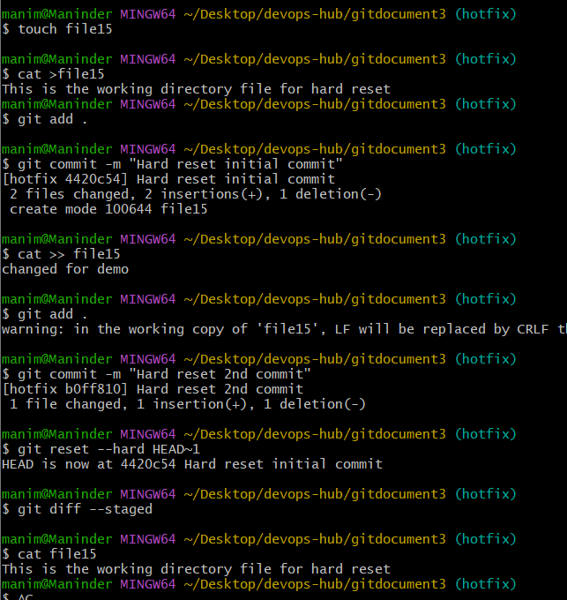

5. Viewing and Comparing Changes (Inspecting changes)
40) git diff: Shows changes between your working directory and
the index (unstaged changes).
41) git diff --staged: Shows changes between the index (staged
files) and the last commit.
42) git diff <commit_id>: Shows the differences between your
working directory and a specific commit.
43) git log: Displays the commit history.
44) git log --oneline: Displays the commit history in a simplified
one-line format.
45) git log --graph: Displays the commit history as a graph.
46) git log --author="name": Filters commits by a specific
author.
47) git log --since="2 weeks ago": Filters commits made
after a specific date.
48) git blame : Shows line-by-line annotations for a file, telling who
last modified each line.
49) git show <commit_id>: Shows details of a specific commit
(including diff and metadata).
50) git show <commit_id>:<file_path>: Shows a specific file
at a particular commit.
6. Reverting and Resetting (Undoing changes)
51) git reset <commit_id>: Moves HEAD to a specific commit,
leaving your working directory intact (can be used with --soft, --
mixed, or --hard).
52) git reset --hard <commit_id>: Resets your working
directory, index, and HEAD to a specific commit (all changes will
be lost).
53) git reset --soft <commit_id>: Resets only the HEAD to a
specific commit, leaving staged changes.
54) git reset --mixed <commit_id>: Resets the HEAD and
index to a specific commit but keeps the working directory
unchanged.
55) git revert <commit_id>: Creates a new commit that undoes
the changes of the specified commit.
56) git restore : Restores the file(s) in the working directory from
the index or a commit.
57) git restore --staged : Removes a file from the staging
area.
58) git clean -f: Removes untracked files in the working
directory.
59) git clean -fd: Removes untracked files and directories.
7. Stashing (Temporarily saving changes)
• git stash: Stashes the changes in your working directory (both
staged and unstaged).
• git stash list: Lists all the stashes.

• git stash pop: Applies the latest stash and removes it from
the stash list.
• git stash apply: Applies a stash without removing it from the
list.
• git stash drop: Removes a specific stash from the stash list.
• git stash clear: Clears all stashes.
• git stash save "message": Stashes changes with an
optional message for identification.
• git stash branch <branch_name>: Creates a new branch
from the stash and applies it.
8. Tags (Managing versions)
• git tag: Lists all tags in the repository.
• git tag <tag_name>: Creates a new tag at the current
commit.
• git tag -a <tag_name> -m "message": Creates an
annotated tag with a message.
• git tag -d <tag_name>: Deletes a tag locally.
• git push origin <tag_name>: Pushes a specific tag to the
remote repository.
• git push origin --tags: Pushes all tags to the remote
repository.
• git fetch --tags: Fetches all tags from the remote
repository.
9. Git Config and Info (Configuration and repository
information)
• git config --global user.name "Your Name": Sets your
global username for commits.
Page | 6
• git config --global user.email
"youremail@example.com": Sets your global email for
commits.
• git config --list: Lists all configuration settings.
• git config : Sets a specific configuration option.
• git config --global core.editor : Sets the default text
editor for Git.
• git config --global color.ui true: Enables colored
output in Git.
• git config --global alias.st status: Creates a custom
Git alias (e.g., git st for git status).
10. Git Aliases (Custom commands)
• git config --global alias.<alias_name>
<actual_command>: Creates a new Git alias for an existing
command.
Example: git config --global alias.co checkout
11. Git Hooks (Automated scripts triggered by Git
actions)
• git init: Creates a .git/hooks directory, where hook scripts are
stored.
• git commit-msg: A hook that runs before a commit message is
saved (you can use this to enforce message formats).
• git pre-commit: A hook that runs before a commit is made
(can be used for checks like linting).
• git post-commit: A hook that runs after a commit is made.
Page | 7
12. Git Submodules (Managing external repositories
within a project)
• git submodule add <repo_url> : Adds a new submodule to
the repository (downloads an external repo).
• git submodule init: Initializes the submodules configured in
the repository (after cloning).
• git submodule update: Updates the submodules to the
commit specified in the superproject.
• git submodule status: Displays the current commit of the
submodule.
• git submodule deinit : Removes a submodule from the
working directory.
• git submodule update --remote: Updates the submodule
to the latest commit from the remote repository.
• git submodule foreach : Runs a command in each
submodule.
13. Git Workflow Commands (Working with others and
managing collaboration)
• git pull --rebase: Fetches and applies remote changes,
rebasing your local commits on top of them.
• git rebase -i <commit_id>: Starts an interactive rebase to
modify commit history (e.g., squash, reword commits).
• git rebase --continue: Continues the rebase after resolving
conflicts.
• git rebase --abort: Aborts the rebase process and restores
the original state.
• git merge --no-ff : Merges a branch with a "no fast-forward"
option to ensure a merge commit is created even when possible
to do a fast-forward merge.
Page | 8
• git pull --no-commit: Pulls changes but doesn't
automatically commit them.
• git push --force-with-lease: Forces push but checks if
the remote branch has been updated (safer than git push --force).
• git push --force: Forces a push to the remote branch,
potentially overwriting changes.
• git cherry-pick <commit_id>: Applies the changes from a
specific commit onto the current branch.
14. Git Merge Strategies (Handling merge conflicts and
strategies)
• git merge --strategy=ours <branch_name>: Resolves
merge conflicts by favoring the current branch’s changes.
• git merge --strategy=theirs <branch_name>: Resolves
merge conflicts by favoring the other branch’s changes.
• git merge --abort: Aborts the merge process if there are
conflicts and restores the working directory.
15. Git bisect (Finding the commit that introduced a bug)
• git bisect start: Starts a binary search for the commit that
introduced a bug.
• git bisect bad: Marks the current commit as "bad" (where
the bug is present).
• git bisect good <commit_id>: Marks a commit as "good"
(where the bug was not present).
• git bisect reset: Ends the bisect process and restores the
repository to the state it was before starting the bisect.
• git bisect log: Displays the log of the bisect process.
Page | 9
16. Git Hooks for Automation (Pre-commit and post-
commit hooks)
• git commit-msg: A hook script that runs before the commit
message is finalized (you can use this to enforce rules, like
requiring certain keywords).
• git pre-commit: A hook that can be used to run checks on files
before the commit is finalized, such as linters or tests.
• git post-commit: A hook that is triggered after a commit has
been completed, useful for triggering actions like notifications or
build processes.
• git pre-push: A hook that runs before a push to the remote
repository is initiated.
• git post-merge: A hook that runs after a merge, ideal for
cleanup or setup tasks.
17. Git Clean and Prune (Cleaning up untracked files and
garbage collection)
• git clean -n: Shows which untracked files would be removed,
but doesn’t actually delete them.
• git clean -f: Removes untracked files from the working
directory.
• git clean -fd: Removes untracked files and directories.
• git gc: Runs garbage collection, cleaning up unnecessary files
and optimizing the repository.
• git prune: Removes objects that are no longer needed
(generally used for cleaning up in repositories with lots of history).
18. Git Archive (Creating a snapshot of the repository)
Page | 10
• git archive --format=tar --
output=<output_file>.tar <branch_name>: Creates a
tarball archive of the repository at a specific branch.
• git archive --format=zip --
output=<output_file>.zip <branch_name>: Creates a zip
archive of the repository at a specific branch.
19. Git Blame and Annotate (Tracing the history of file
content)
• git blame <file_path>: Shows who last modified each line
of a file and when.
• git annotate <file_path>: An alias for git blame, which
displays commit information for each line of a file.
20. Git Reflog (Tracking changes in the HEAD reference)
• git reflog: Displays a log of all movements of the HEAD
pointer (useful for tracking changes like reset and rebase
operations).
• git reflog show: Displays a detailed view of HEAD and the
state of the repository.
• git reflog expire --expire=now --all: Removes all
reflog entries that have expired.
• git reflog delete <ref_id>: Deletes a specific reflog entry.

